13.48: a) Solving Eq. (13.39) for I,
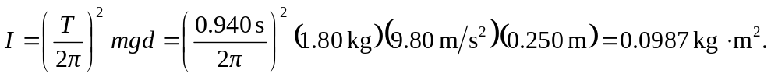
b) The small-angle approximation will not give three-figure accuracy for 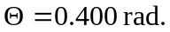 From energy considerations,
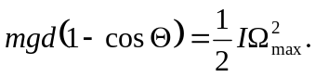
Expressing 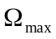in terms of the period of small-angle oscillations, this becomes
